Maxmaran’s One-Month Journey: Exploring Vietnam, Cambodia, Turkey, and Sri Lanka
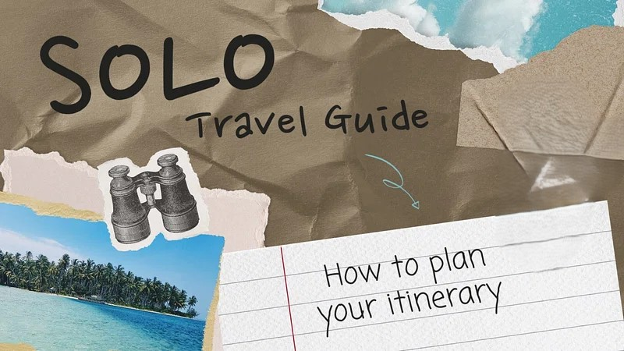
Traveling across borders is more than ticking off destinations — it's about diving into cultures, tasting authentic food, wandering through history, and experiencing nature at its best. This is exactly what Maxmaran set out to do on his epic one-month adventure that connected Vietnam, Cambodia, Turkey, and Sri Lanka. With just a few clicks, he secured the necessary Visas for each country and stepped into a world of unforgettable memories.
First Stop: Vietnam – A Harmony of Tradition and Modernity
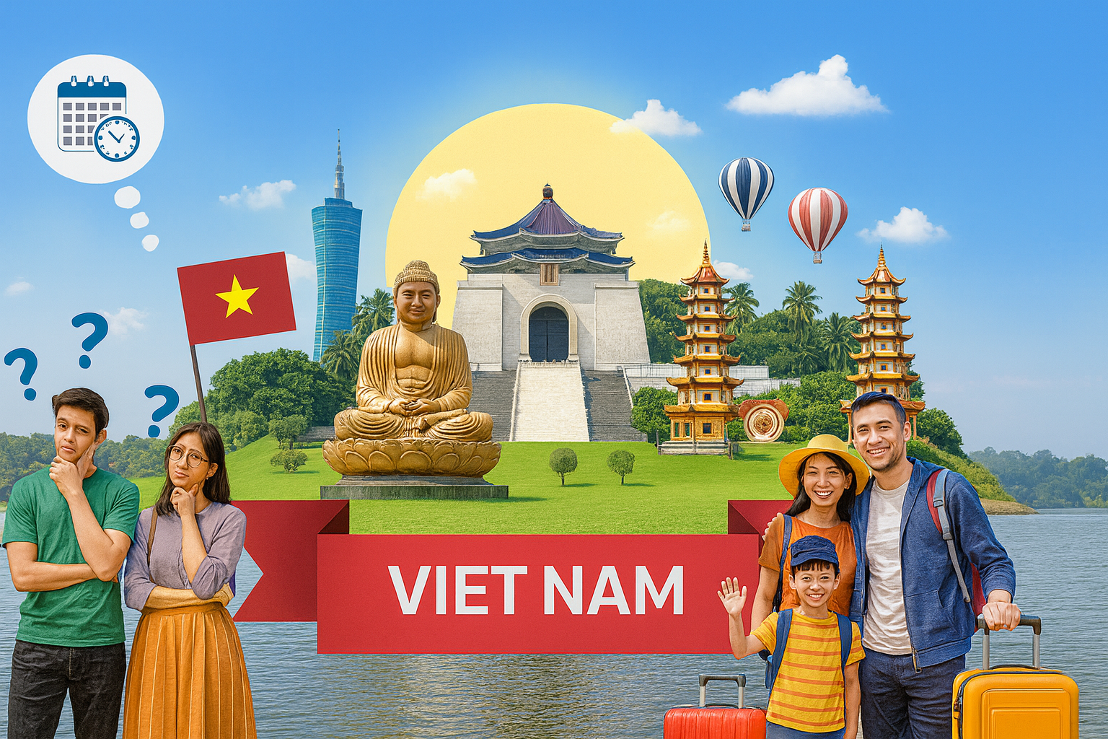
Armed with his backpack and a hunger for adventure, Maxmaran landed in Hanoi, Vietnam’s capital, where old-world charm meets modern energy. The bustling Old Quarter immediately pulled him in with its maze of narrow streets filled with vendors, scooters, and the scent of sizzling street food.
Maxmaran dove into Vietnamese cuisine — sampling steaming bowls of Pho, crispy Banh Xeo, and flavorful Bun Cha. The food here wasn’t just nourishment; it was a cultural language of herbs, broths, and bold textures.
From the towering limestone cliffs of Ha Long Bay to the misty rice terraces in Sapa, Vietnam’s natural beauty is unmatched. He wandered through ancient towns like Hoi An, cycled along the riverbanks, and climbed the Marble Mountains.
He also explored deep-rooted Vietnamese history at sites like the Imperial City of Hue and the War Remnants Museum in Ho Chi Minh City — gaining new appreciation for the country’s resilience and strength.
✅ Applying for the Vietnam Visa was straightforward and quick, allowing Maxmaran to enter the country with confidence and flexibility for his travel dates.
Next: Cambodia – Temples, Culture, and Calm
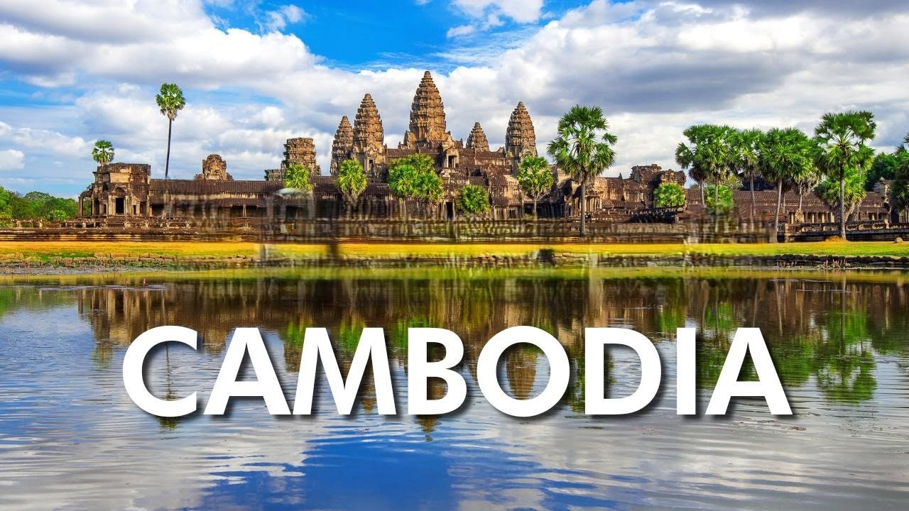
Maxmaran crossed into Cambodia with a plan: witness the world-famous Angkor Wat. When the sun rose behind the ancient towers of this massive temple complex, he felt a spiritual calm unlike anything before. The temples of Angkor — including Bayon and Ta Prohm — stood as silent guardians of Cambodia’s grand past.
He explored Phnom Penh, where he confronted the sobering truths of Cambodia’s history at the Killing Fields and the Tuol Sleng Genocide Museum. The balance between loss and hope deeply moved him.
Cambodian cuisine introduced him to Amok, Lok Lak, and unique local desserts. He took cooking classes with Khmer locals and enjoyed slow meals by the river in Battambang.
The countryside, peppered with rice fields, floating villages, and lush mountains, gave him a different kind of peace. He also took a few days to relax on Koh Rong, where white sands and turquoise water stretched for miles.
✅ With the Cambodia Visa, Maxmaran was able to skip embassy queues and focus entirely on his travel experience. The digital visa process made entry smooth and stress-free.
Third Destination: Turkey – Timeless Cities and Natural Wonders
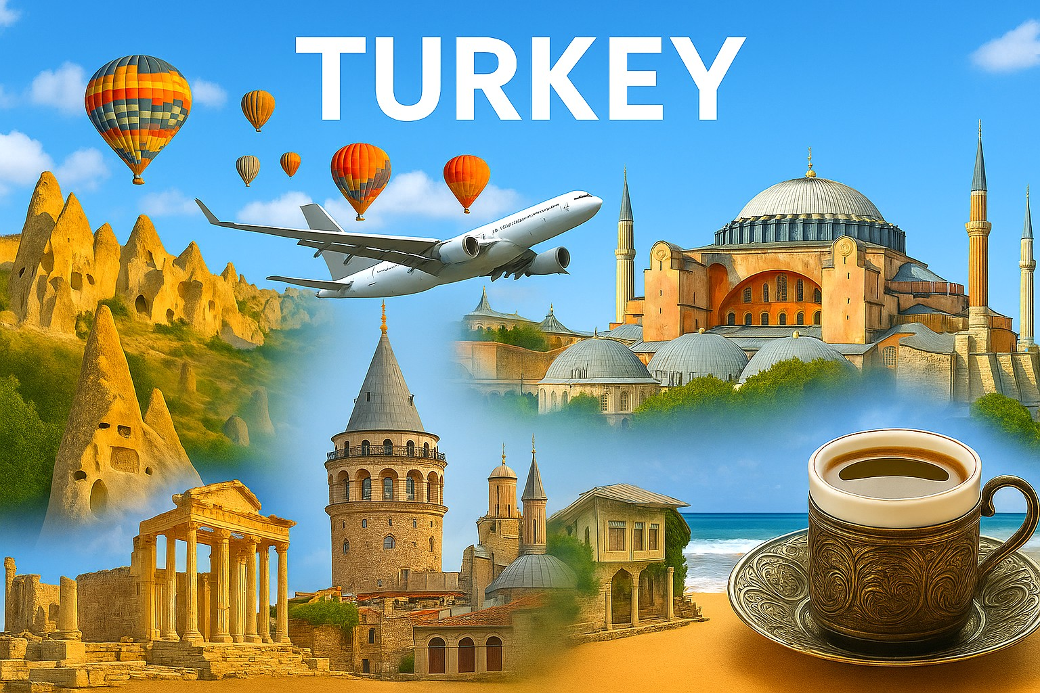
Maxmaran flew into Istanbul, where Europe and Asia meet. The call to prayer, the scent of spices, and the grandeur of the Hagia Sophia welcomed him to a land of contrasts. He wandered through the Blue Mosque, sampled delights at the Spice Bazaar, and took in stunning views on a Bosphorus cruise.
In Cappadocia, he soared in a hot air balloon over fairy chimneys. In Pamukkale, he bathed in ancient thermal springs. He strolled among Roman ruins in Ephesus, learning how Turkey’s history reflects a blend of ancient empires and rich cultures.
The food scene was a revelation — from sizzling Adana kebabs to syrupy baklava and fresh pide. Maxmaran shared meals with locals, always ending the night with strong Turkish tea or coffee.
Turkey offered both bustling city life and serene landscapes — a perfect mix of adventure and reflection.
✅ The Turkey Visa gave him seamless access to this cross-continental treasure. The online process was fast, allowing Maxmaran to explore the country without administrative hassle.
Final Leg: Sri Lanka – The Pearl of the Indian Ocean
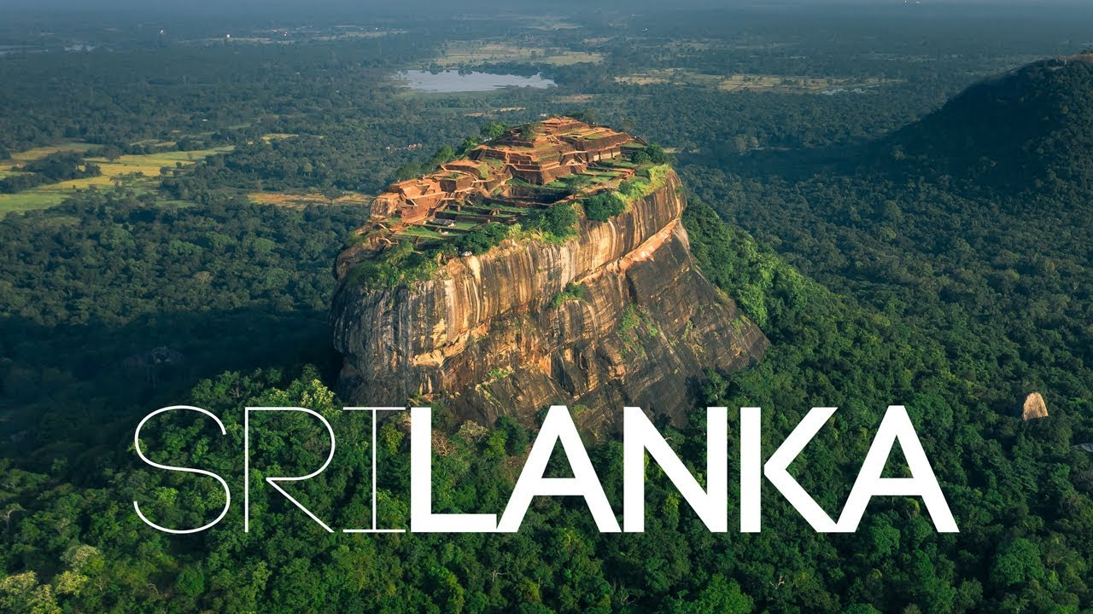
Arriving in Sri Lanka, Maxmaran was greeted by palm trees and ocean breezes. His journey began in Colombo, but the real magic unfolded as he rode the scenic train from Kandy to Ella. With tea plantations on one side and waterfalls on the other, the ride was a highlight of the entire trip.
He climbed Little Adam’s Peak, stood beneath the Nine Arches Bridge, and ventured into the ancient city of Polonnaruwa, where ruins whispered stories of a glorious past. The cultural triangle, filled with temples and stupas, showcased Sri Lanka’s rich Buddhist heritage.
Maxmaran found the food in Sri Lanka bold and hearty — devouring kottu, hoppers, and spicy fish curry. He learned to eat with his hands, enjoying the tactile connection to the cuisine.
In Mirissa, he joined a whale-watching tour, glimpsing blue whales breaching just offshore — a reminder of how nature still holds powerful mysteries.
✅ With the quick approval of his Sri Lanka Visa, Maxmaran entered the country without delays. It allowed him more time to dive into adventure, nature, and culture without bureaucracy standing in the way.
Final Reflections by Maxmaran
"One month, four countries, endless stories. This journey wasn’t just about moving across maps — it was about connecting with the soul of each place. Vietnam gave me flavor, Cambodia offered spiritual silence, Turkey blended worlds into one, and Sri Lanka grounded me with its raw natural beauty.
Every country had a different rhythm, yet all welcomed me warmly — thanks in large part to the ease of the Vietnam e-Visa, Cambodia e-Visa, Turkey e-Visa, and Sri Lanka e-Visa. These digital visas not only saved time but also gave me freedom. Freedom to explore, to eat, to connect.
If you're dreaming of a multi-country adventure, let the eVisa systems open the door. The world is waiting — and it’s easier than ever to say yes.”

